Sat/Sun 5/6 Sep

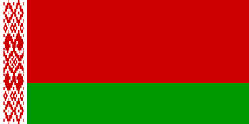
Weekend
FOCC WEST LOTHIAN DAILY BLOG 2015
It has been a lovely weekend of sunny Scottish weather and the children and interpreters have made the most of it with their host families.
There have been many interesting outings, some with just host families, some with small groups of host families and culminating in a barbeque at one host family's house on Sunday afternoon where the majority of the children attended.
Much fun was had by all and hopefully some rest and relaxation was squeezed in too, as Monday sees the start of our second week of activities.

